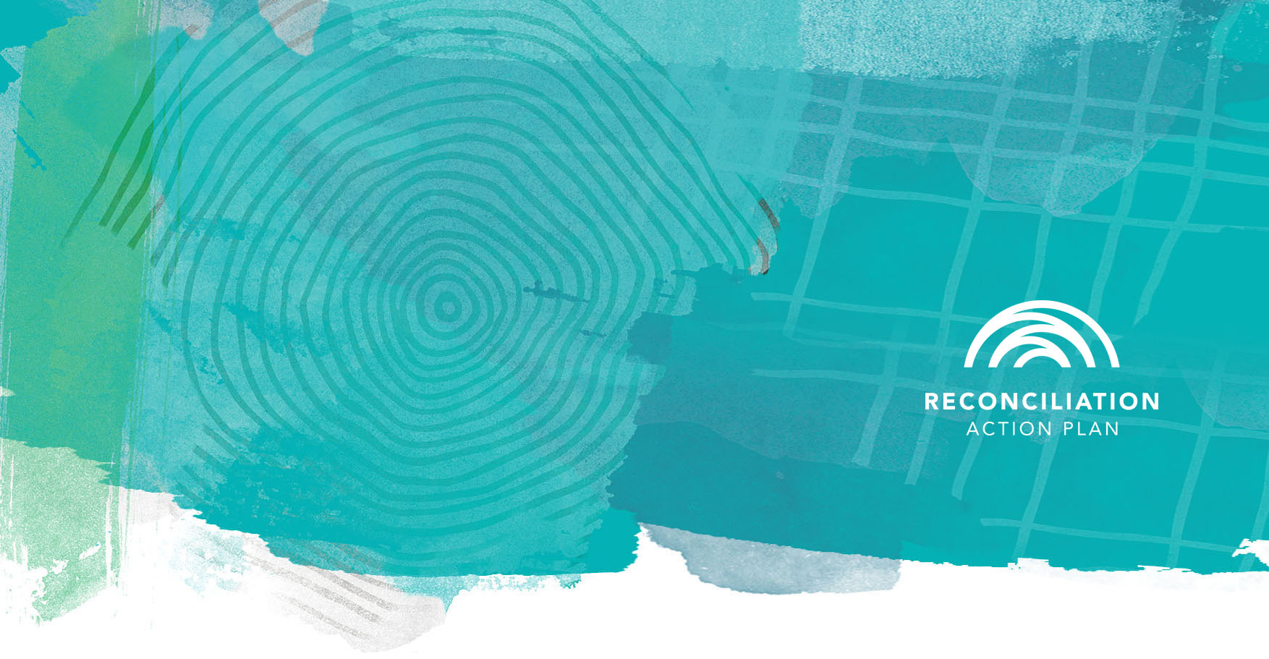
Take part in the 2026 Workplace RAP Barometer
2026 Workplace RAP Barometer
The WRB is a national survey from Reconciliation Australia that measures the attitudes and experiences of employees in organisations with Reconciliation Action Plans. It helps us understand how reconciliation is experienced in our workplace and in workplaces across the country.
The WRB is a proven tool that helps RAP organisations strengthen the impact of their RAPs. Your responses help:
INSERT QR CODE LINK TO YOUR SURVEY HERE IF NEEDED. OTHERWISE REMOVE THIS TEXT BOX
- Show how we’re performing compared to our peers
- Identify what’s working well and where to focus our attention
- Measure our progress against national benchmarks
Contribute to national change
Aggregated WRB results are compared to the concurrent Australian Reconciliation Barometer (ARB) and show how RAP organisations are influencing reconciliation outcomes.
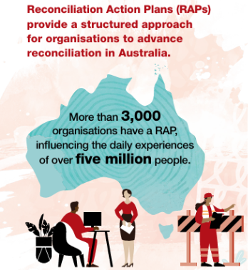
The survey has run every two years since 2012. In 2024:
- 230+ RAP organisations participated
- 33,000+ employees shared their views
Your voice is safe
Your individual responses are not shared with your employer. Participating organisations will receive a summary report only.
Takes just 15 minutes
Survey closes [ADD YOUR ORGANISATION’S DATE]
Any questions? [ADD YOUR CONTACT]

